**CS5542 Big Data Apps and Analytics**

**In Class Programming –10**

**4th November 2021**

**Due Date: 11/11/2021 (Thursday by 11:59pm)**

**Deep Q-Learning:**

**Implementing Deep Q-Learning in Python using Keras & OpenAI Gym:**

In deep Q-learning, we use a neural network to approximate the Q-value function. The state is given as the input and the Q-value of all possible actions is generated as the output. The comparison between Q-learning & deep Q-learning is illustrated below:

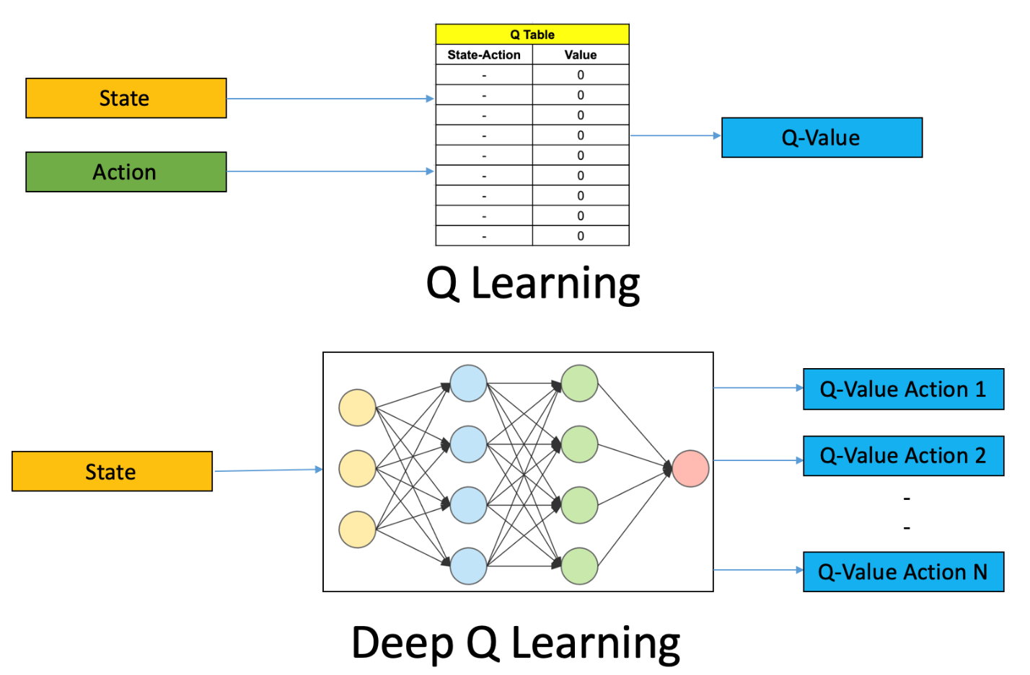

CartPole is one of the simplest environments in the OpenAI gym (a game simulator). The idea of CartPole is that there is a pole standing up on top of a cart. The goal is to balance this pole by moving the cart from side to side to keep the pole balanced upright.

Design a Deep Q learning Network (DQN), using Keras & OpenAI Gym , for cartpole game and visualize your results.

ICP Requirements:

1. Designing a DQN for cartpole game in python using Keras & OpenAI Gym
2. Visualization of DQN cartpole game
3. overall code quality
4. Wiki Report quality, video explanation

Submission Guidelines:

Same as previous ICPs.

Submission Link :

<https://classroom.github.com/a/dOoVPbUY>